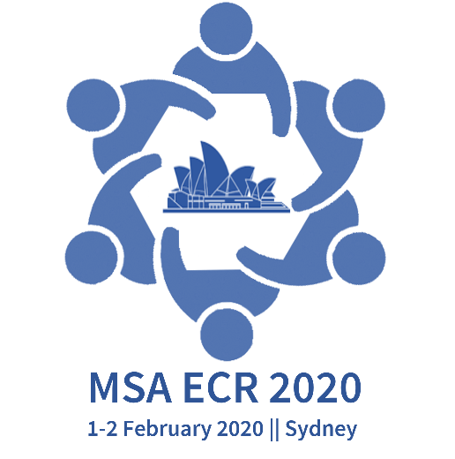 | Membrane Society of Australia  Early Career Researcher  Membrane Symposium  1-2 February 2020 || University of Technology Sydney, Australia

Title: MSA-ECR 20 symposium Abstract Template
Author 1ª (Presenting Author underlined), Author 2^{b}, Author 3^{c}, Author 4ª*
ª Affiliation 1
^{b} Affiliation 2
^{c} Affiliation 3
*Corresponding author: email, telephone

Abstract:
Title and Author list: The font size for abstract title is 14, bold and that for author affiliations is 11.
Main text: The abstract should be written in English, no longer than 300 words and fit within two A4 page. The font type is Times New Roman. The font size for abstract title is 14, bold and that for author affiliations is 11. The font size for all the other text is 12. Please use single line space, intention left 0.5 cm (first line only), margins top, left, right, bottom all 2.5 cm.

Keywords: up to 5 keywords

Presenting author details
Full name:
Email:
Contact number:
Affiliation:
Would you like to be considered for a presentation award (Student and ECR only, please check eligibility on www.msaecr20.com)?: Yes / No

